ASSIGNMENT 1
- To capture live network packets using Wireshark and identify basic network protocols such as TCP, UDP, IP, and DNS.

Step 1: Launch Wireshark
- Open Wireshark
- You will see a list of network interfaces
  - Wi-Fi
  - Ethernet

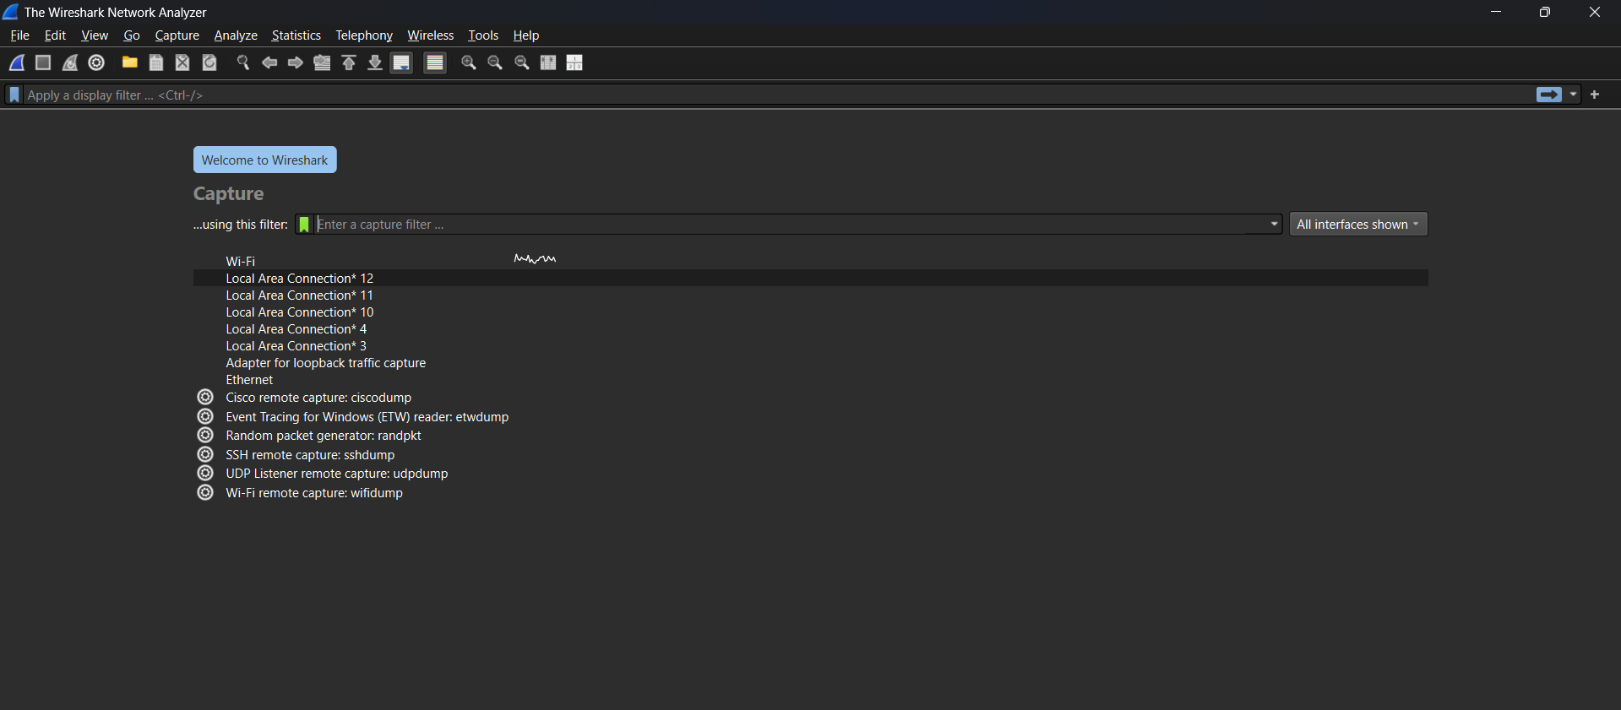

Step 2: Start Packet Capture
- Double-click on Wi-Fi (or active interface)
- Packet capture will start immediately
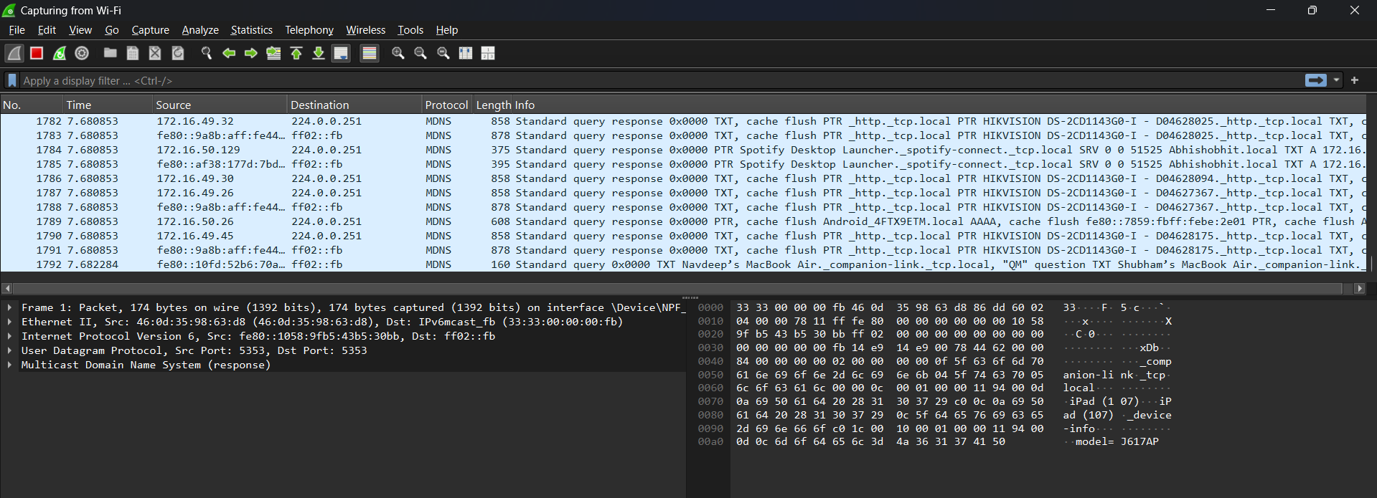

Step 3: Generate Network Traffic
Perform any of the following:
- Open a web browser
- Visit any website (e.g., google.com)
- Open Command Prompt and run:
- ping google.com

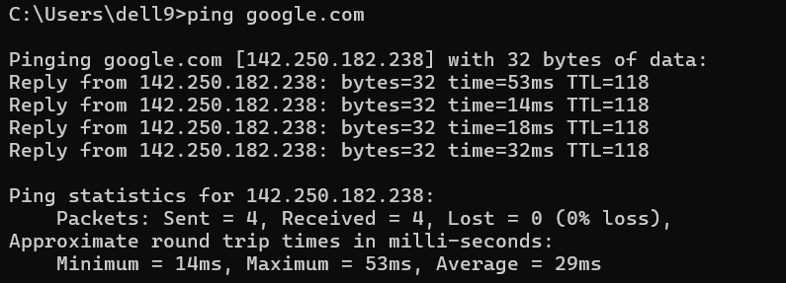

Step 4: Stop Capture
- Click the red Stop button
- Captured packets will remain on the screen

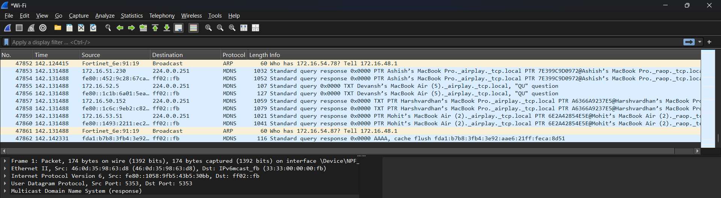

Step 5: Apply Basic Filters
Use the Display Filter bar:
Filter | Purpose
ip | Show IP packets
tcp | Show TCP packets
udp | Show UDP packets
dns | Show DNS packets
icmp | Show ping packets

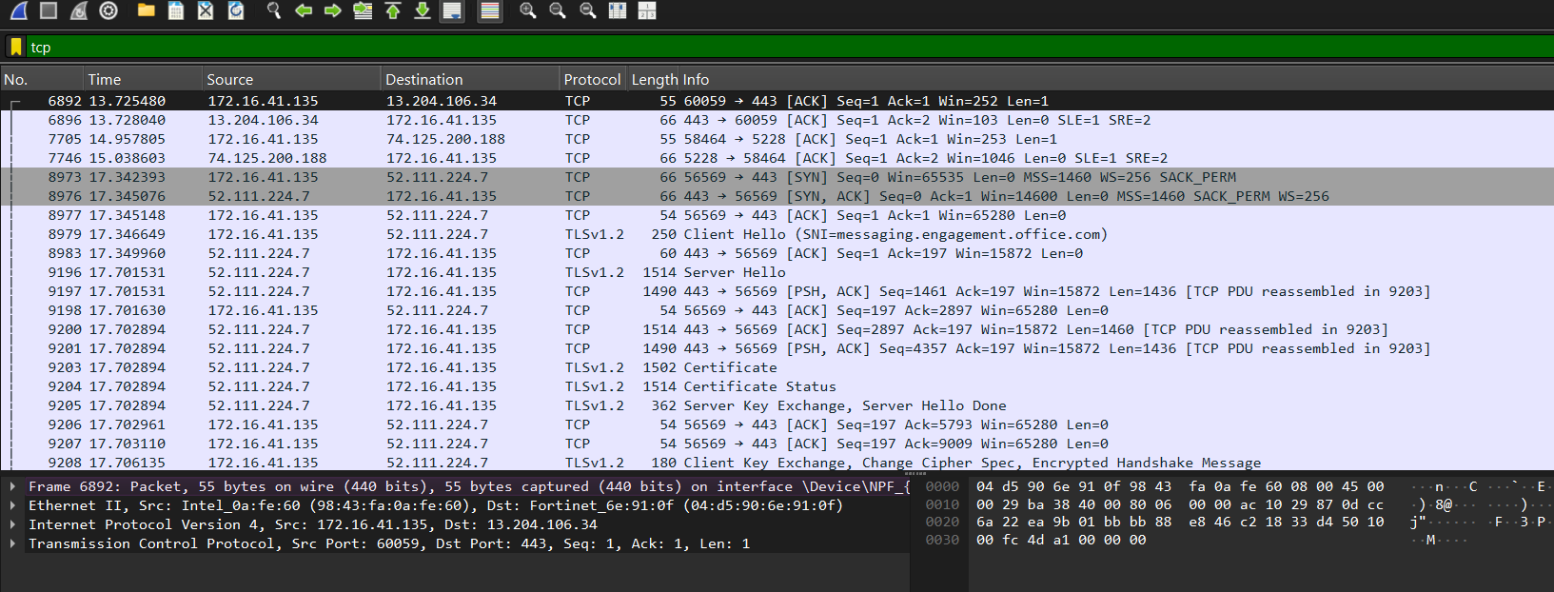

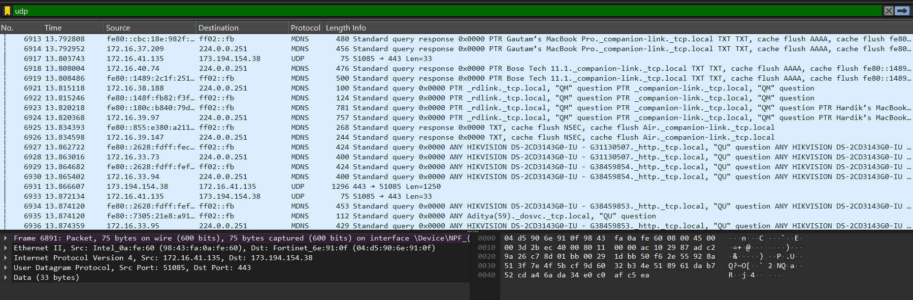

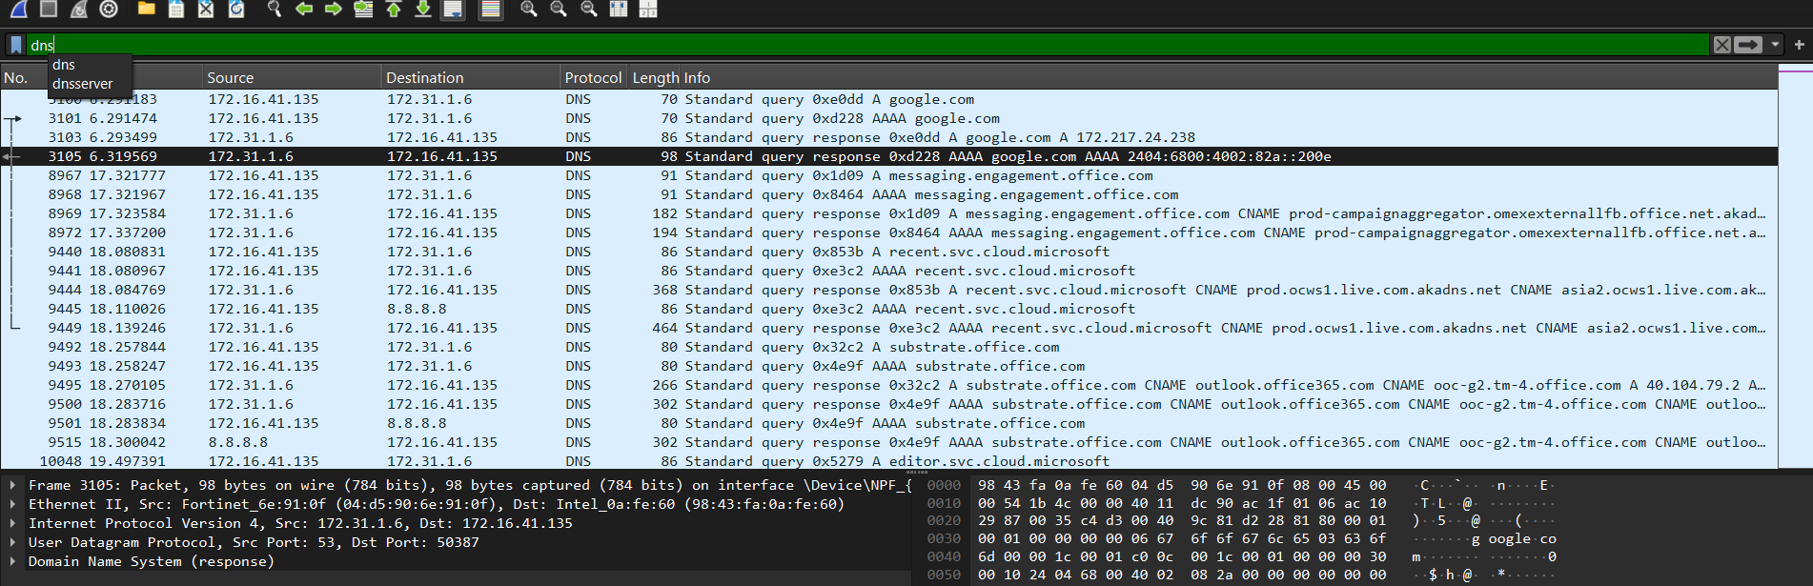
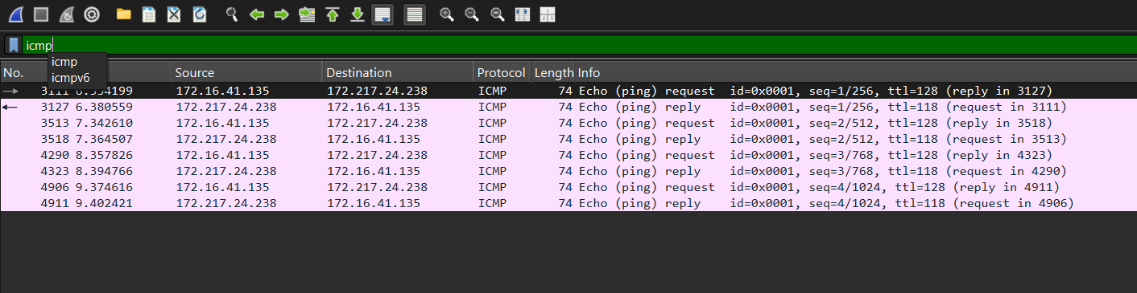
Step 6: Analyze a Packet
- Click on any packet
- Observe:
  - Ethernet header
  - IP header
  - TCP/UDP header
  - Payload data

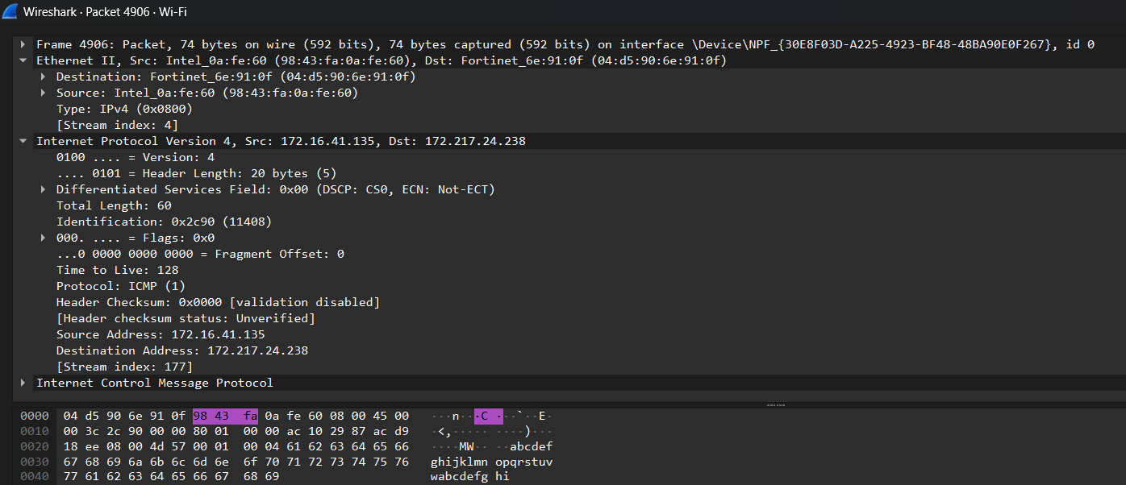

📊 Observation
Interface used:
- Protocols observed:
- Source and destination IP addresses
- Packet length

Result
Live network packets were successfully captured using Wireshark, and basic network protocols were identified and analyzed.

ASSIGNMENT 2

- To capture and analyze ICMP packets (Ping request and reply)

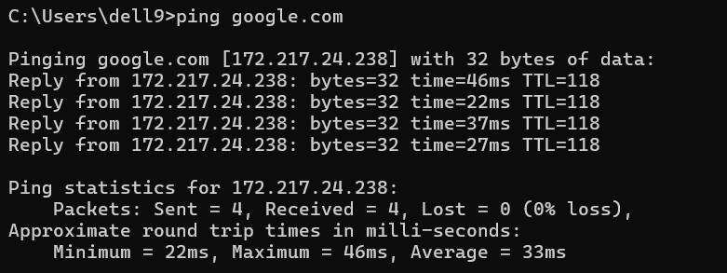
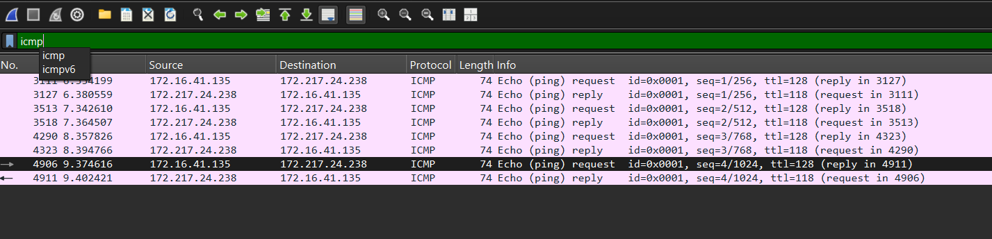

- To analyze TCP packets and observe the TCP three-way handshake

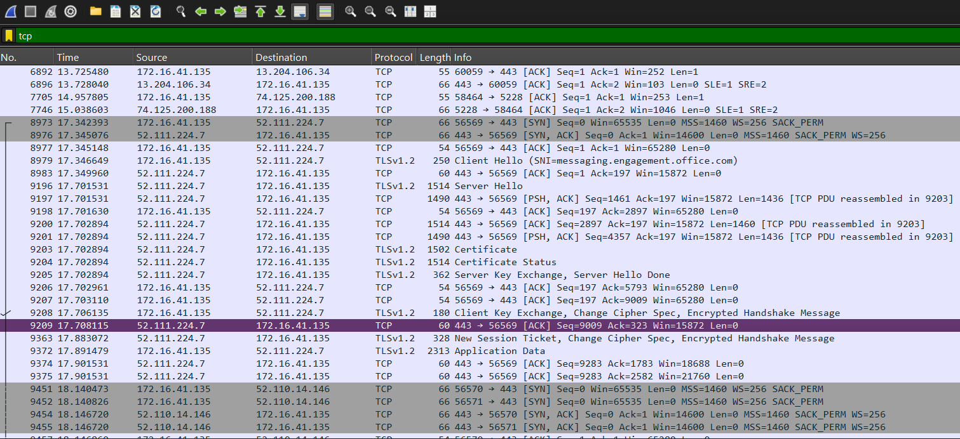

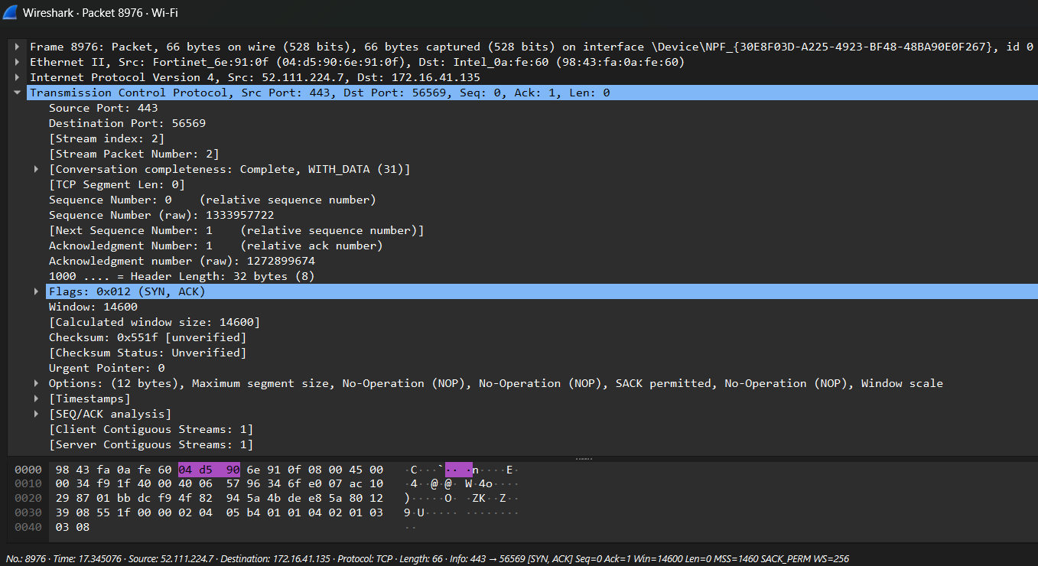

- To capture and analyze UDP packets

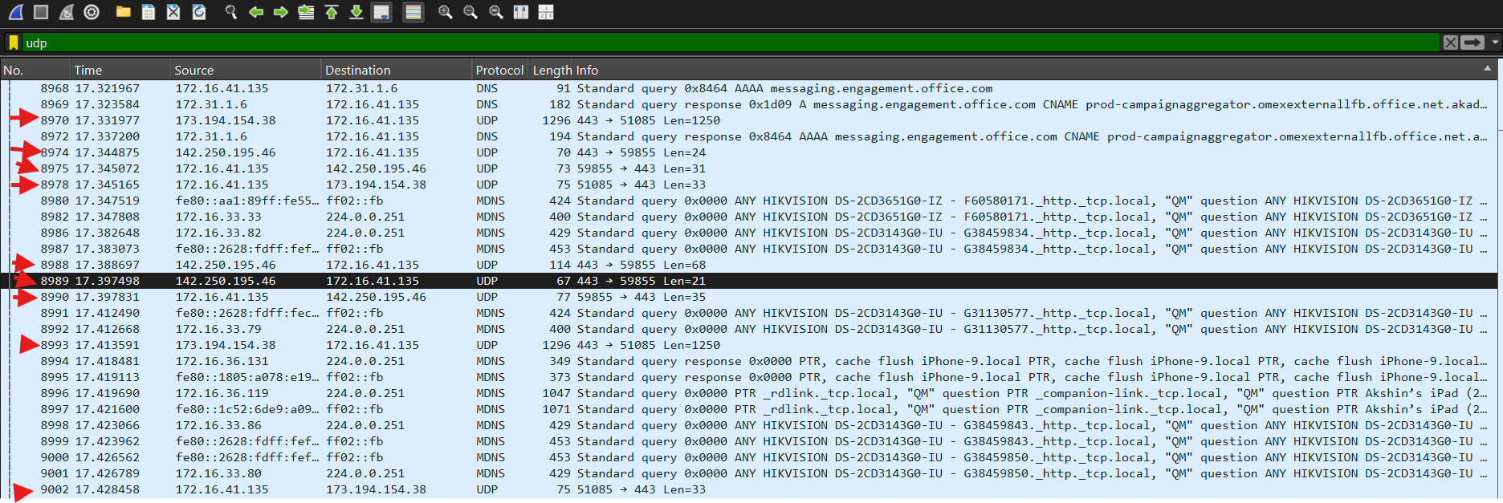
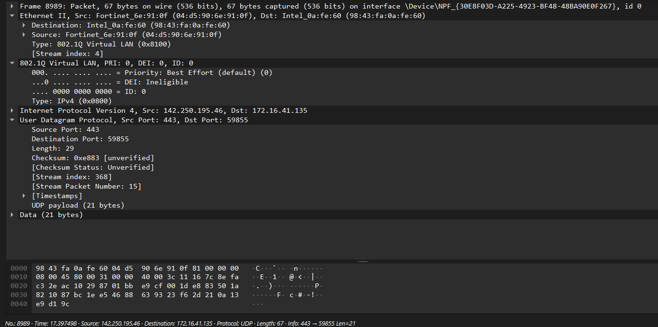

- To capture and analyze DNS query and response packets

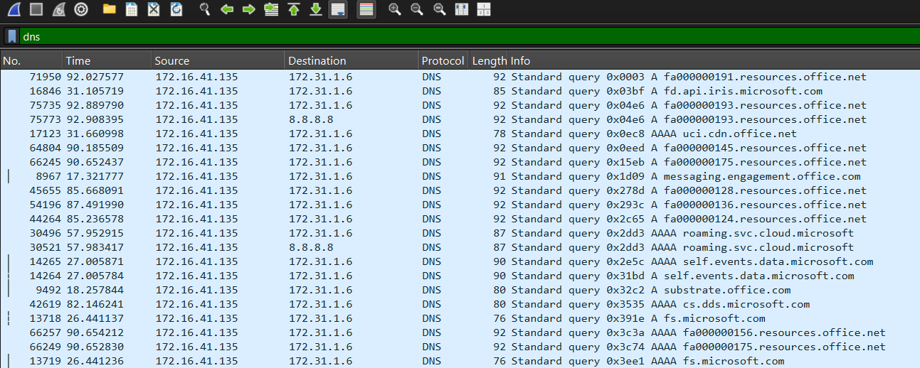

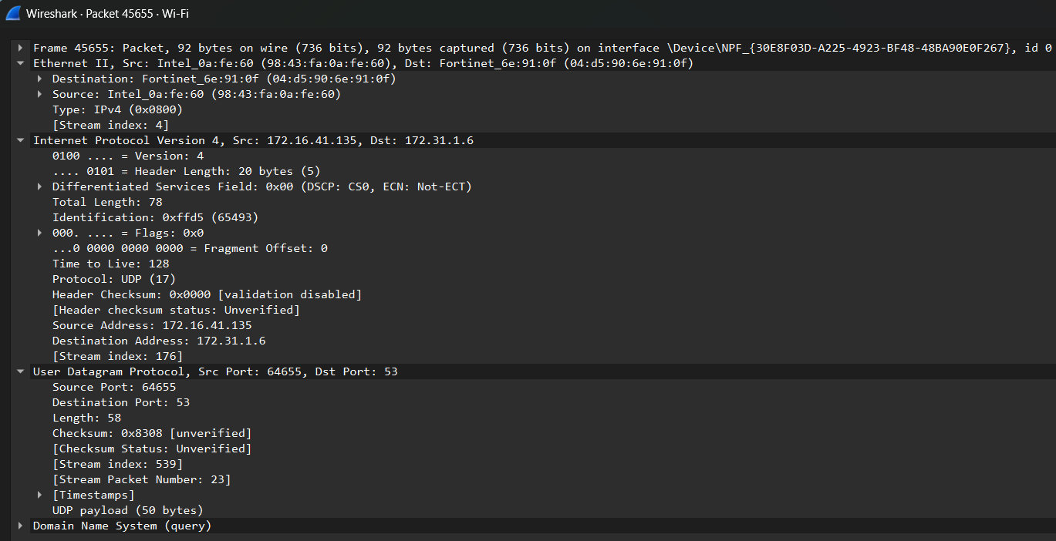

- To capture and analyze HTTP packets

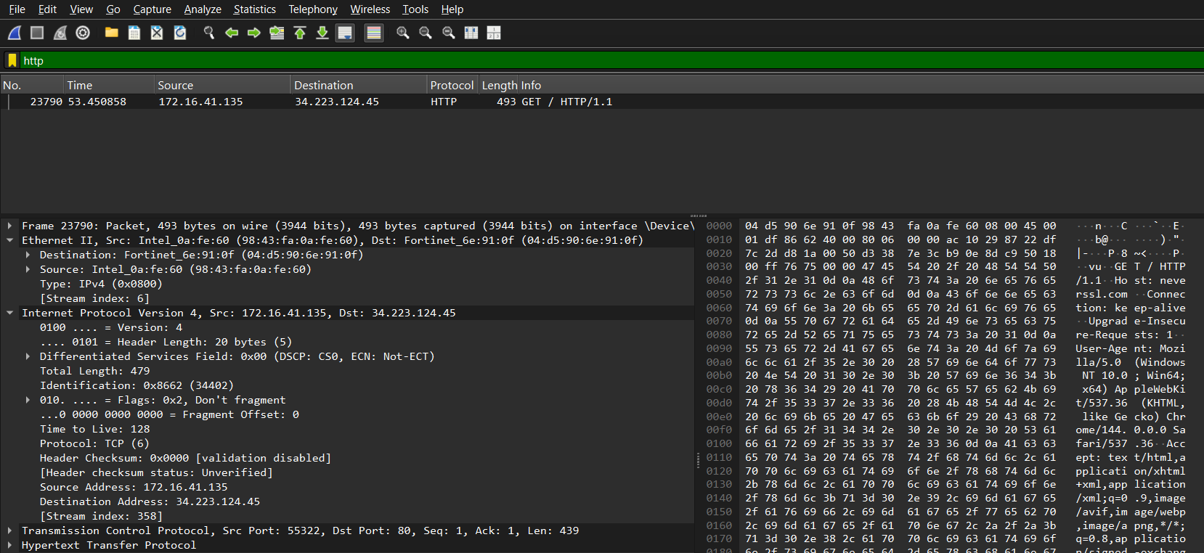

- To analyze ARP request and reply packets

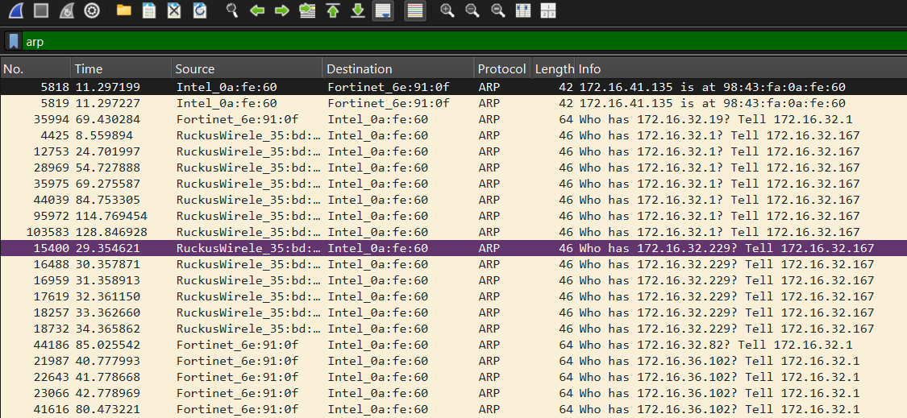

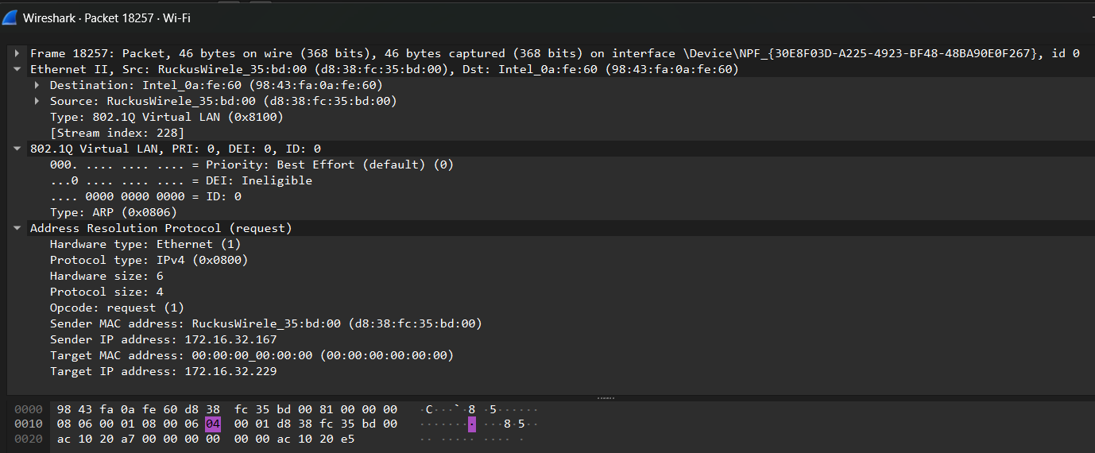

- To identify source and destination MAC and IP addresses in captured packets.

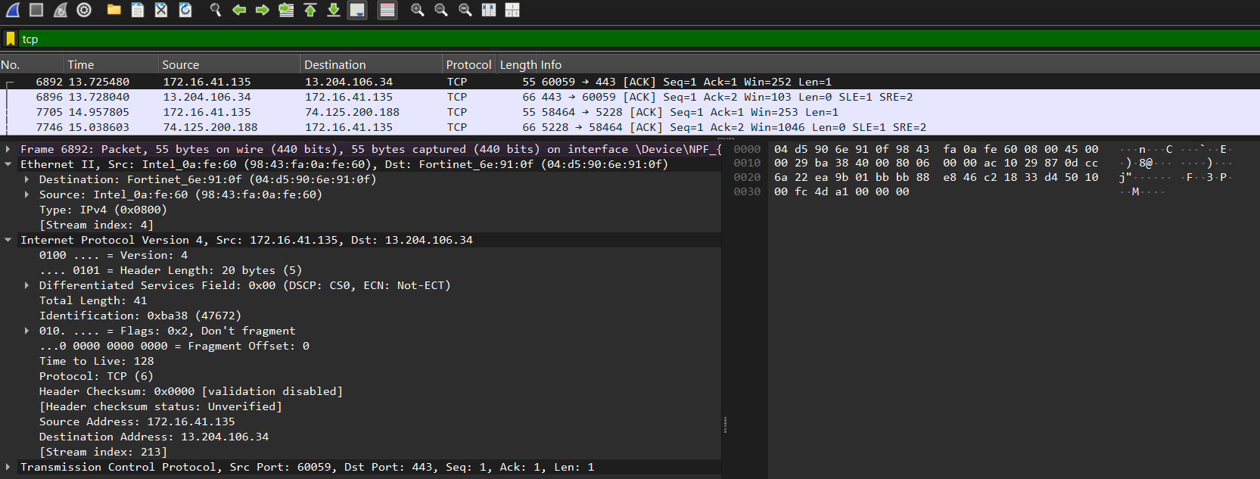

ASSIGNMENT 3

Ans.1
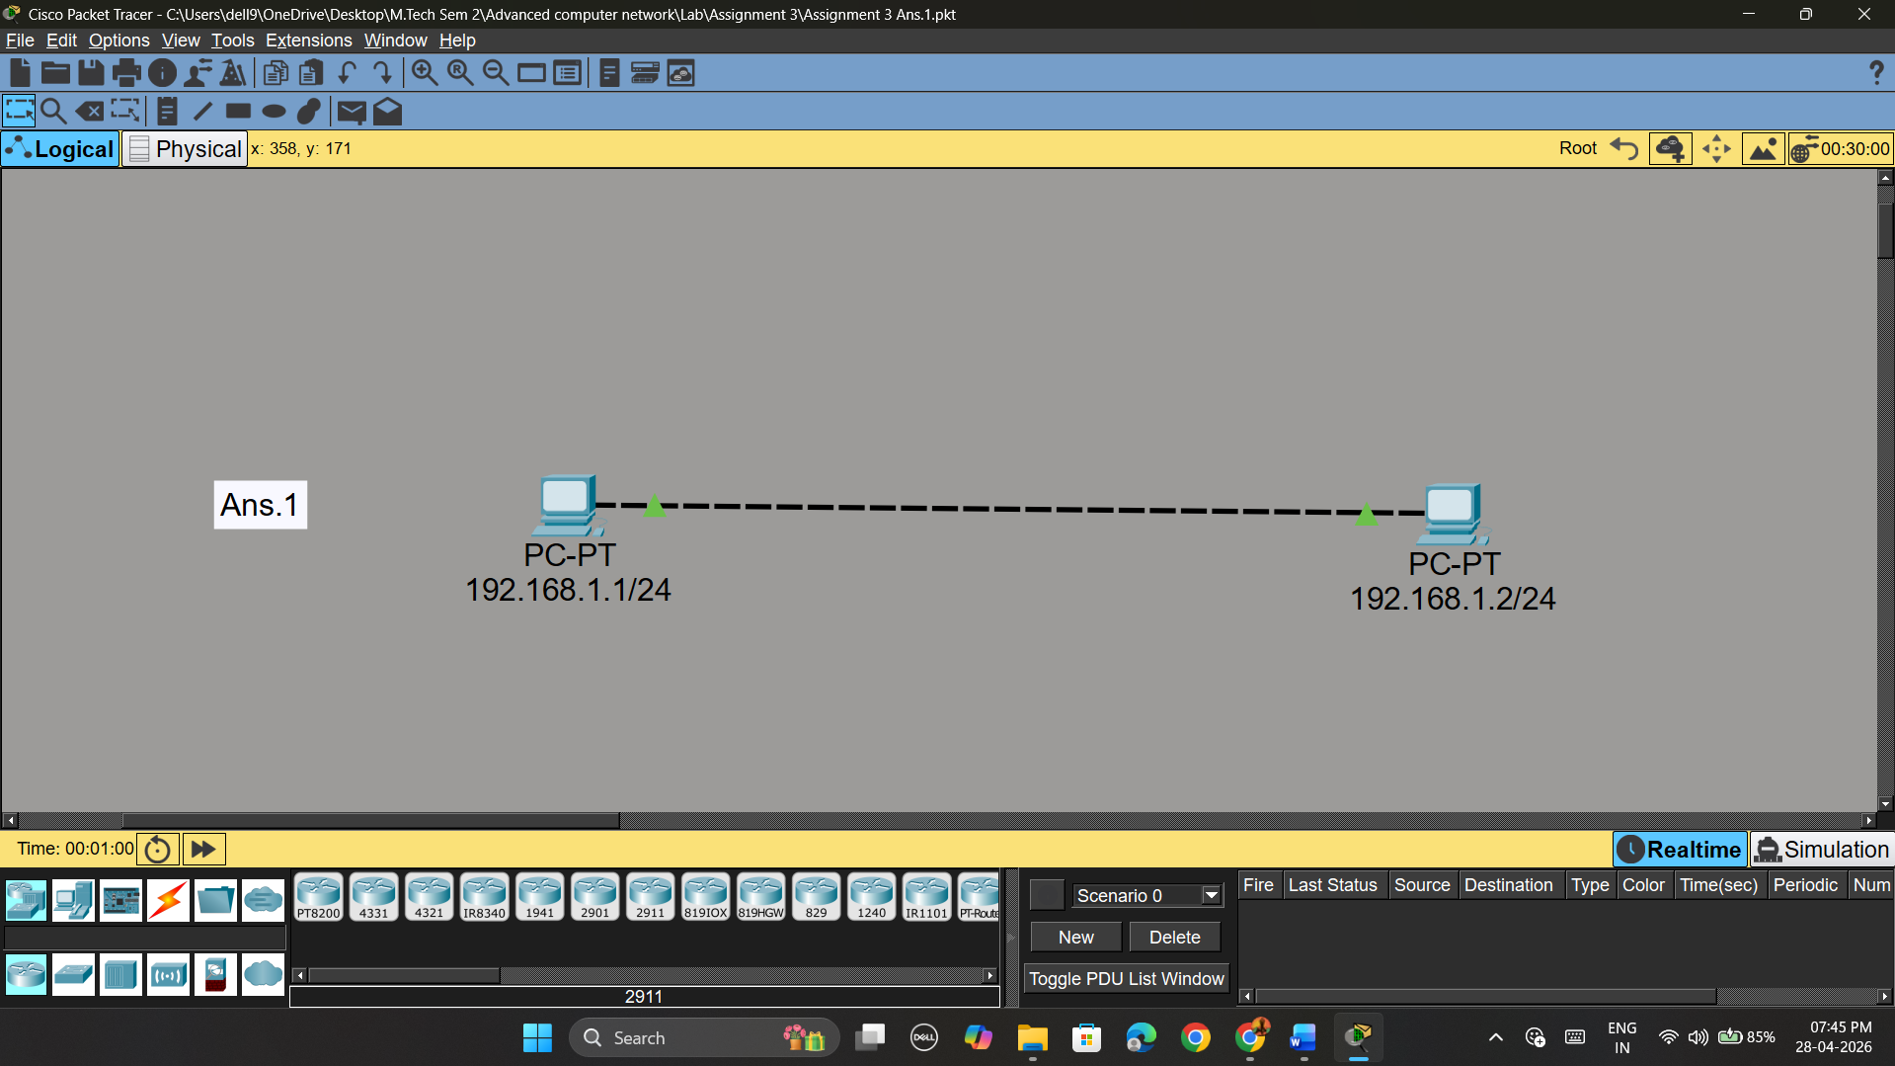

Ans.2
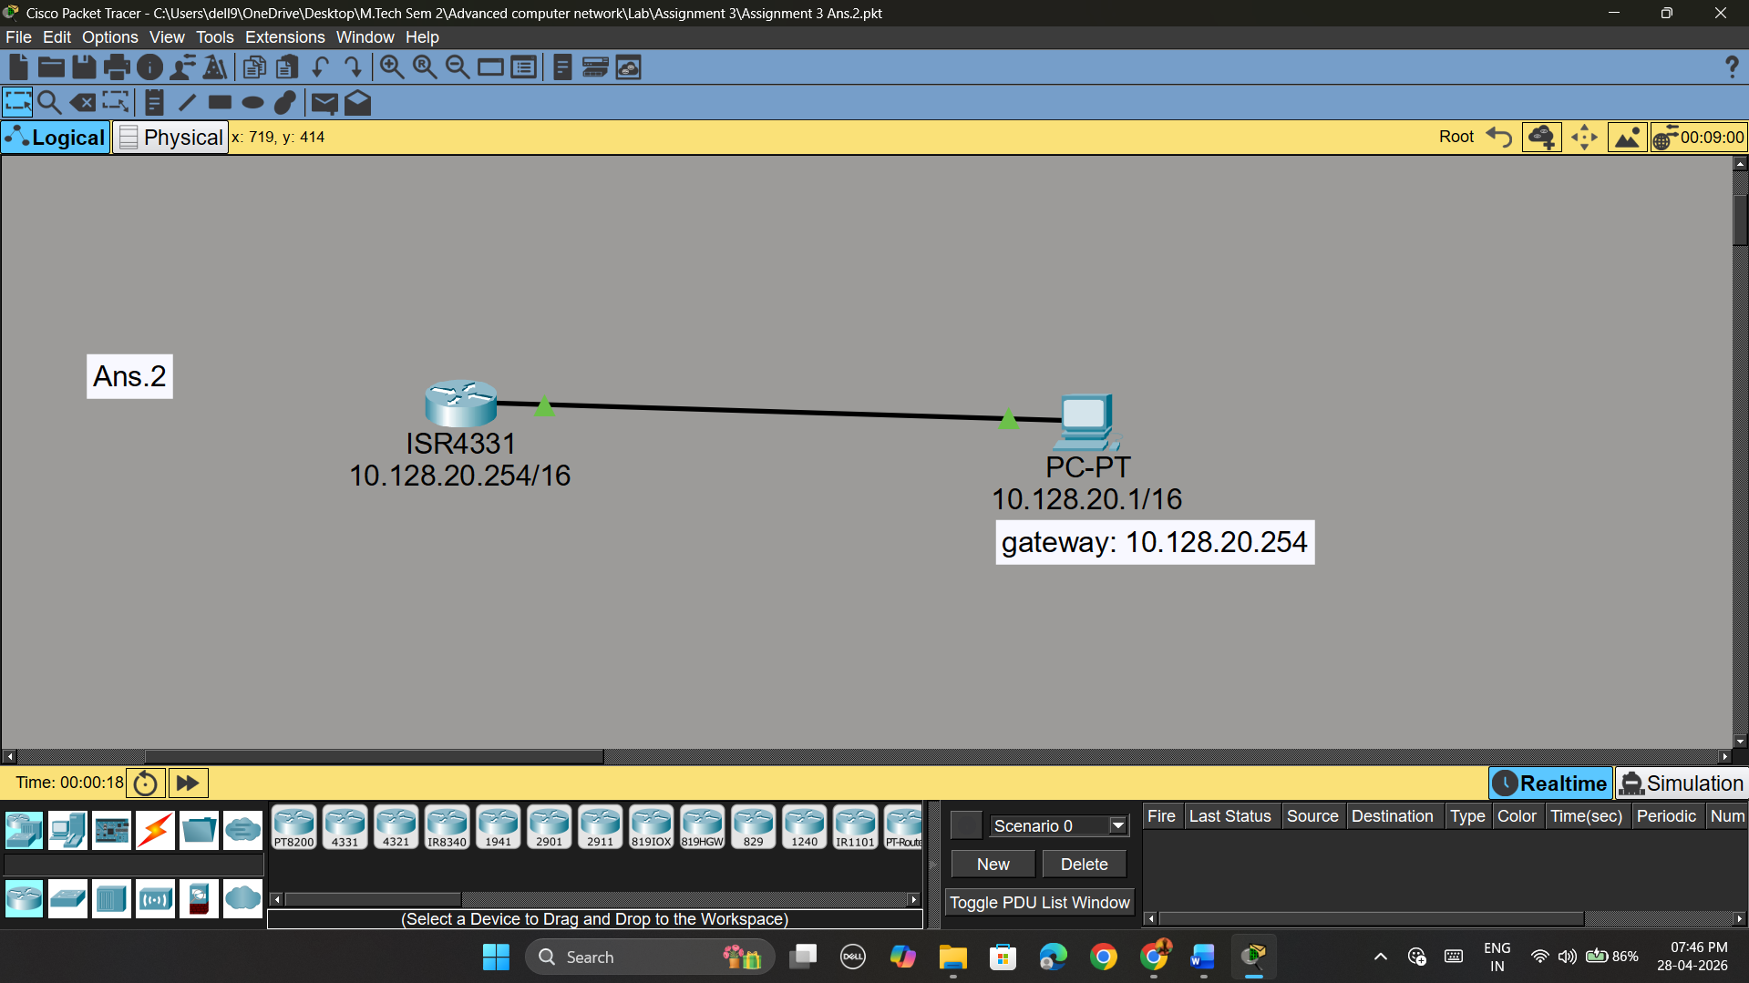
Ans.3
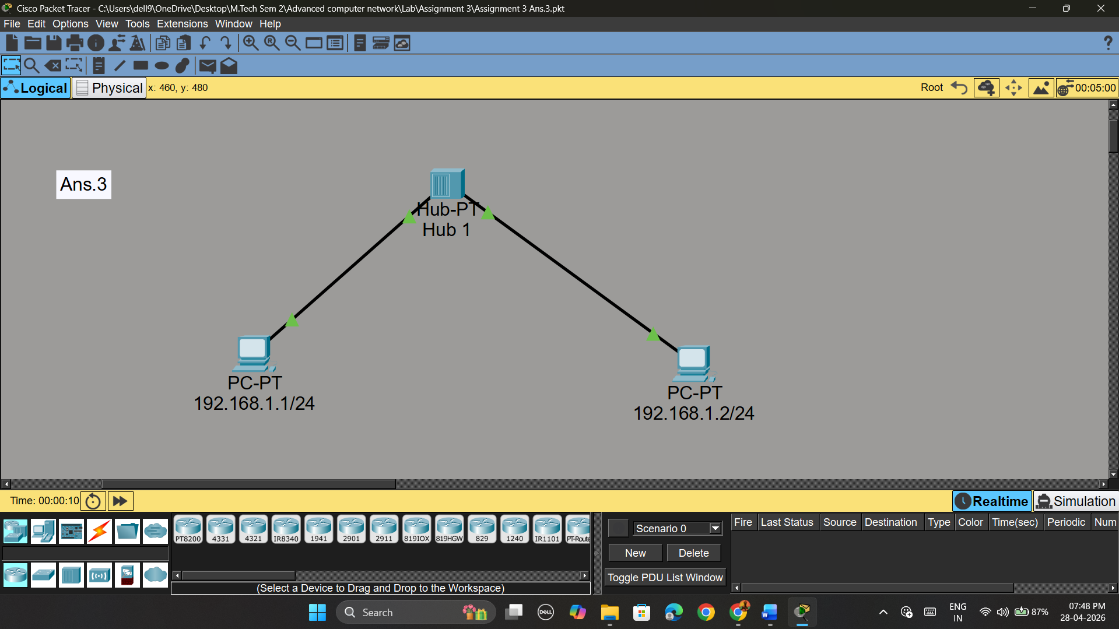

Ans.4
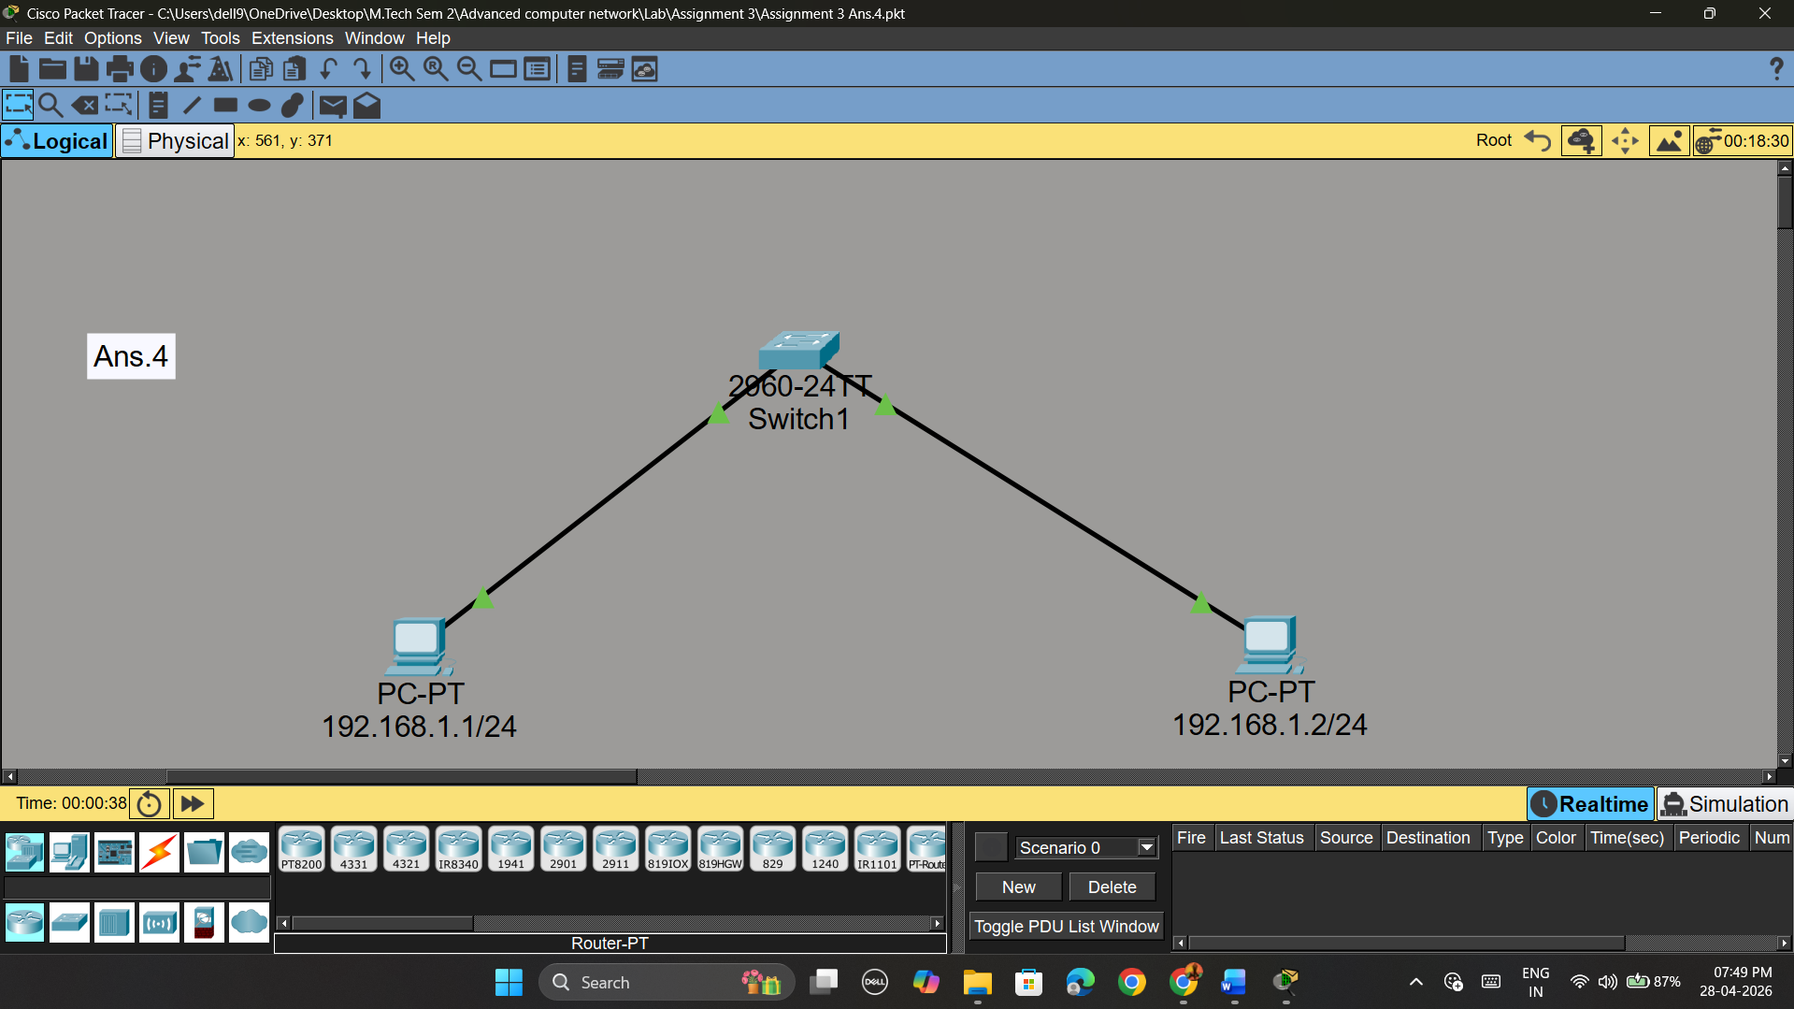
Ans.5(a)
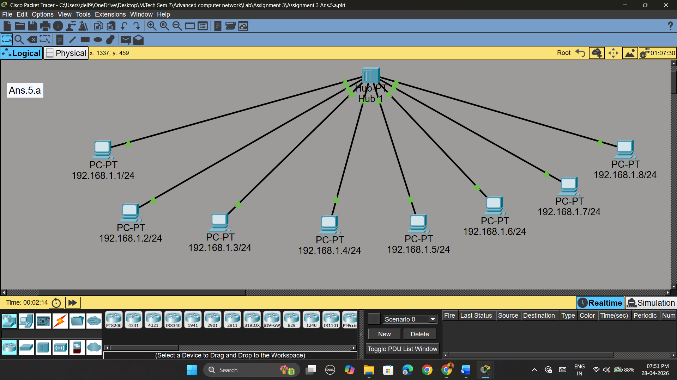

Ans.5(b)
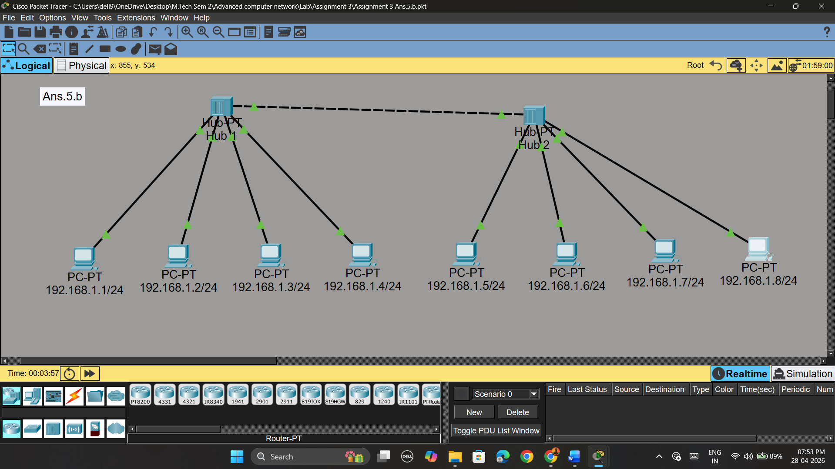
Ans.6
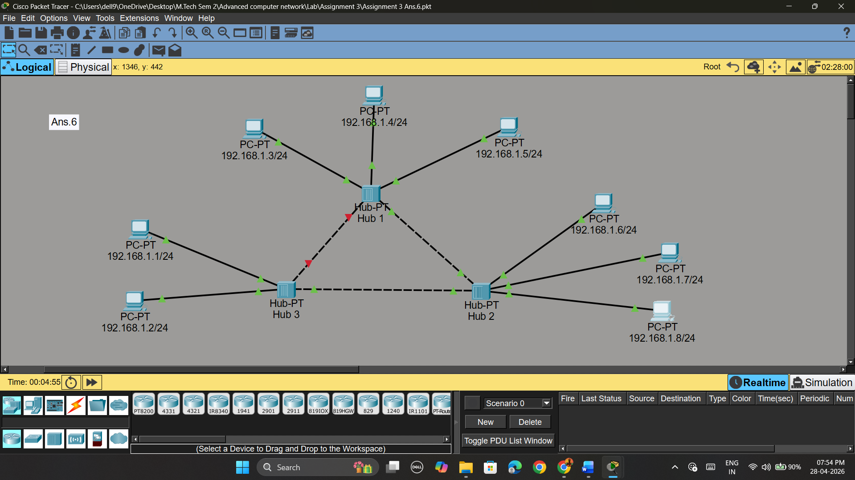
Ans.7
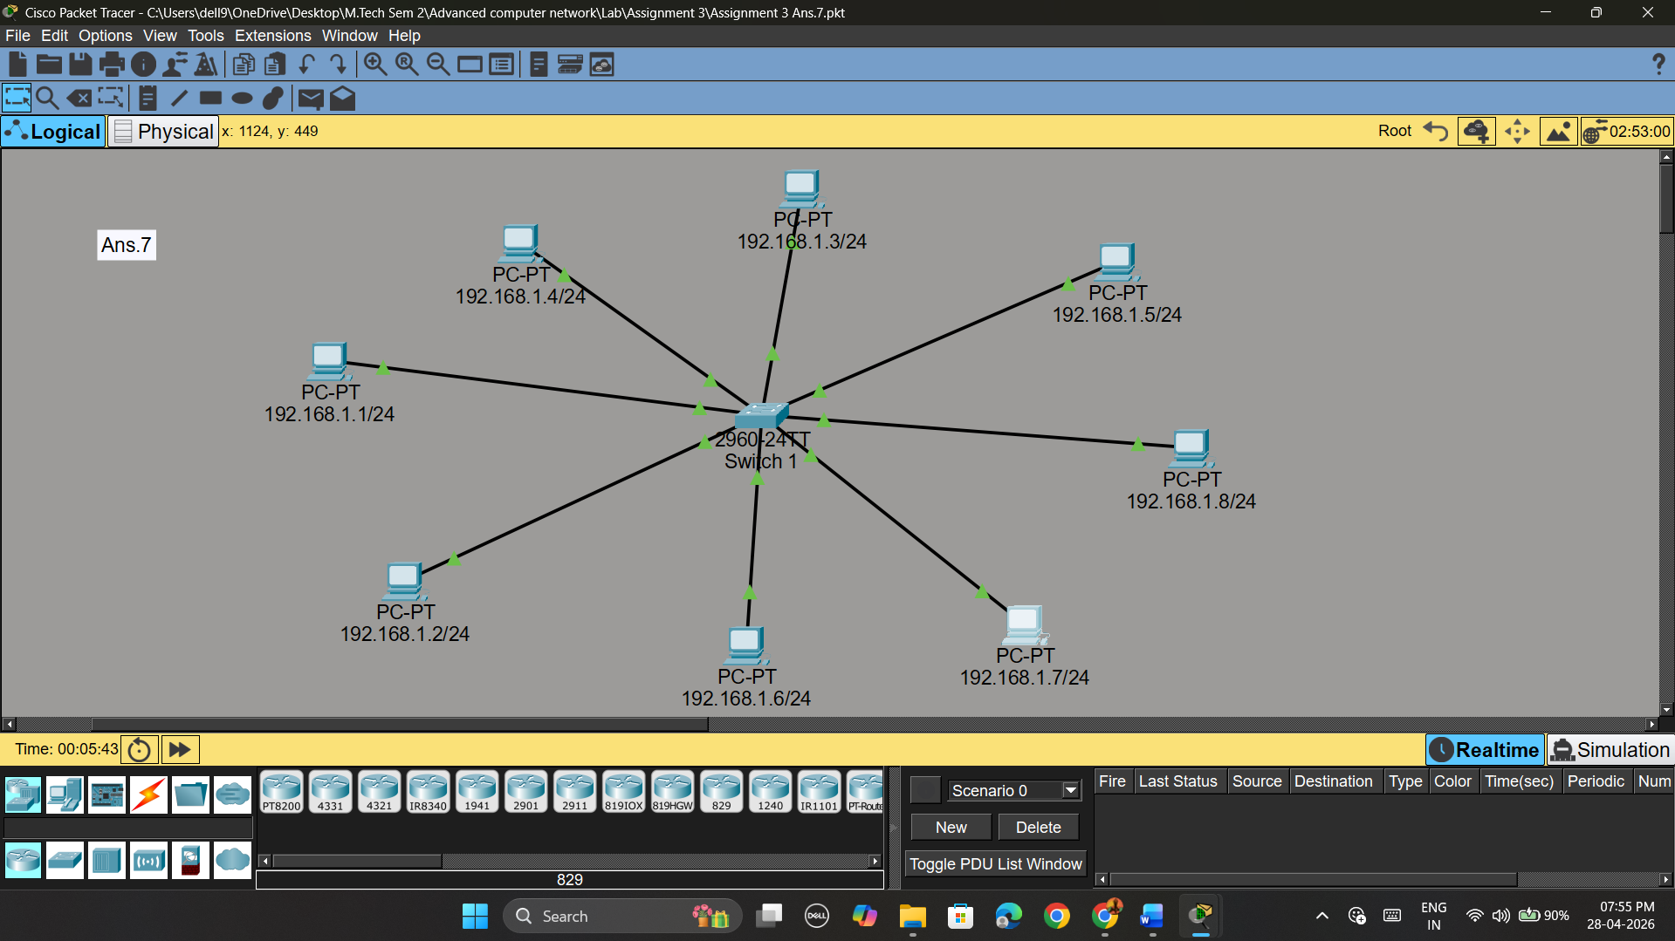
Ans.8
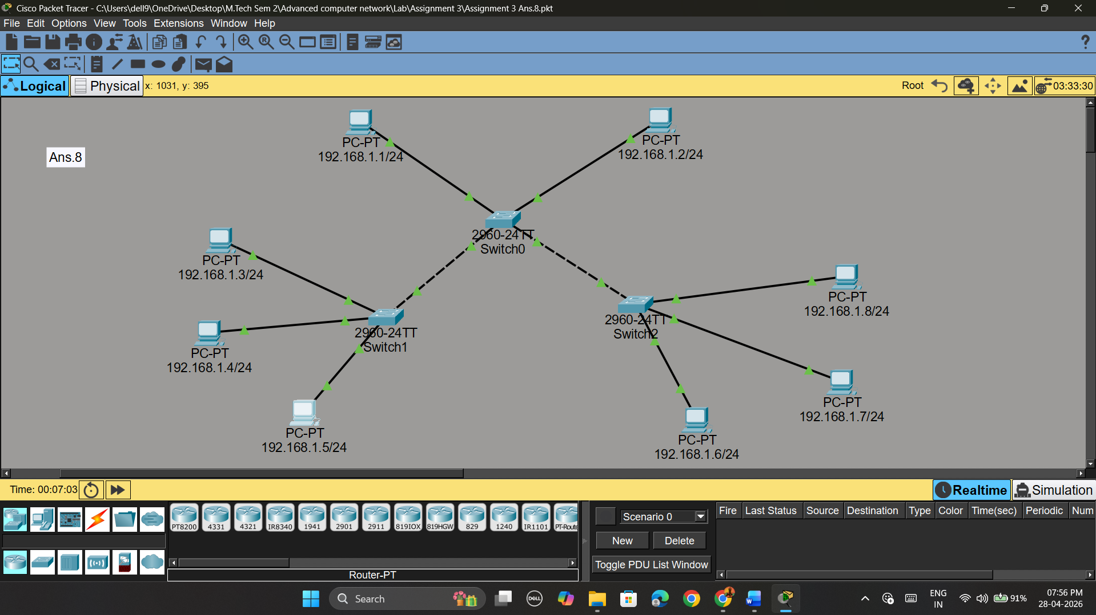

ASSIGNMENT 4

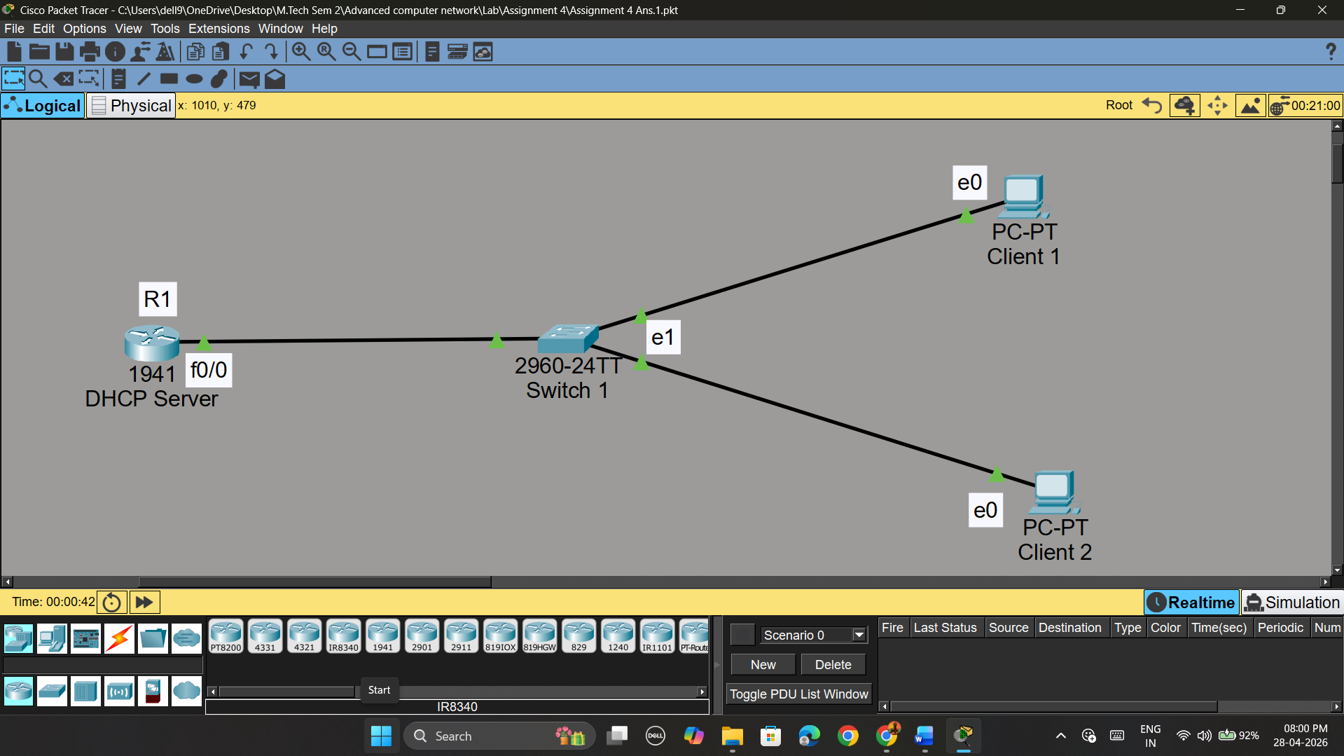

ASSIGNMENT 5
Ans.1
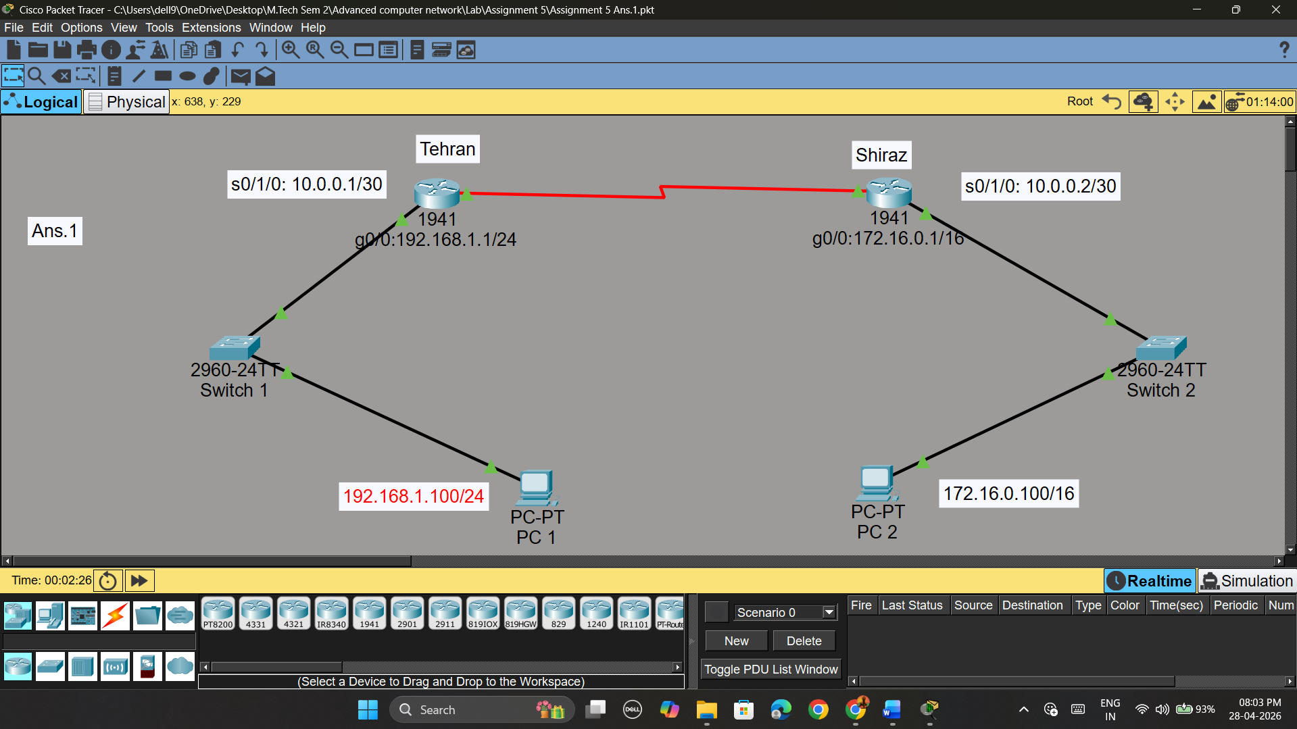

Ans.2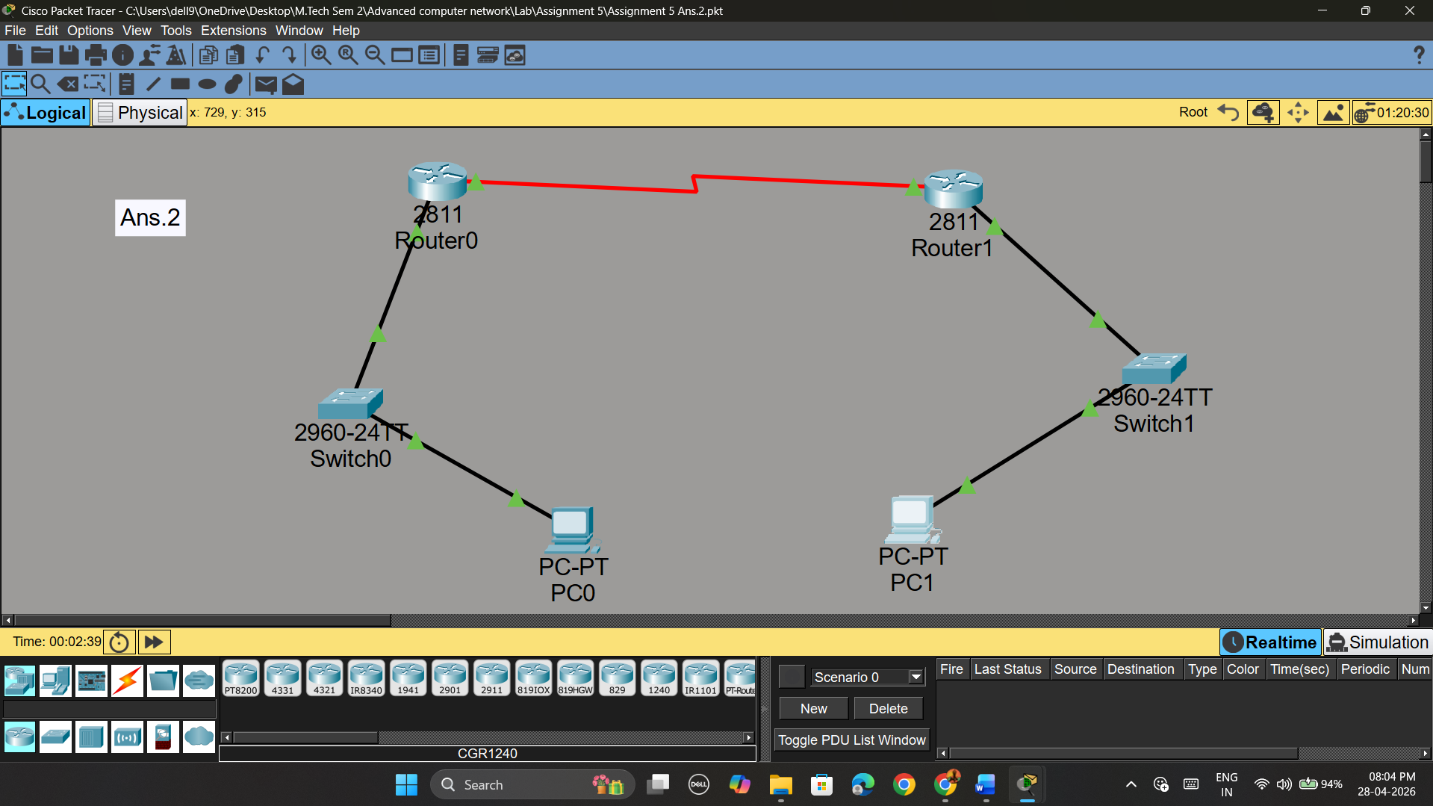
Ans.3
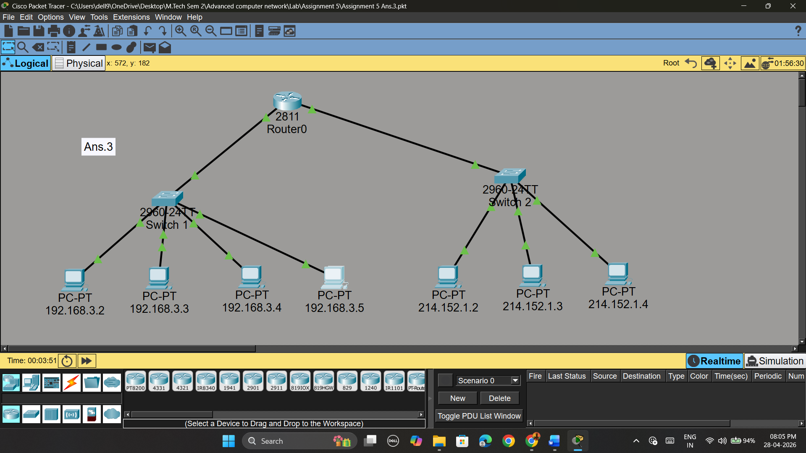

ASSIGNMENT 6

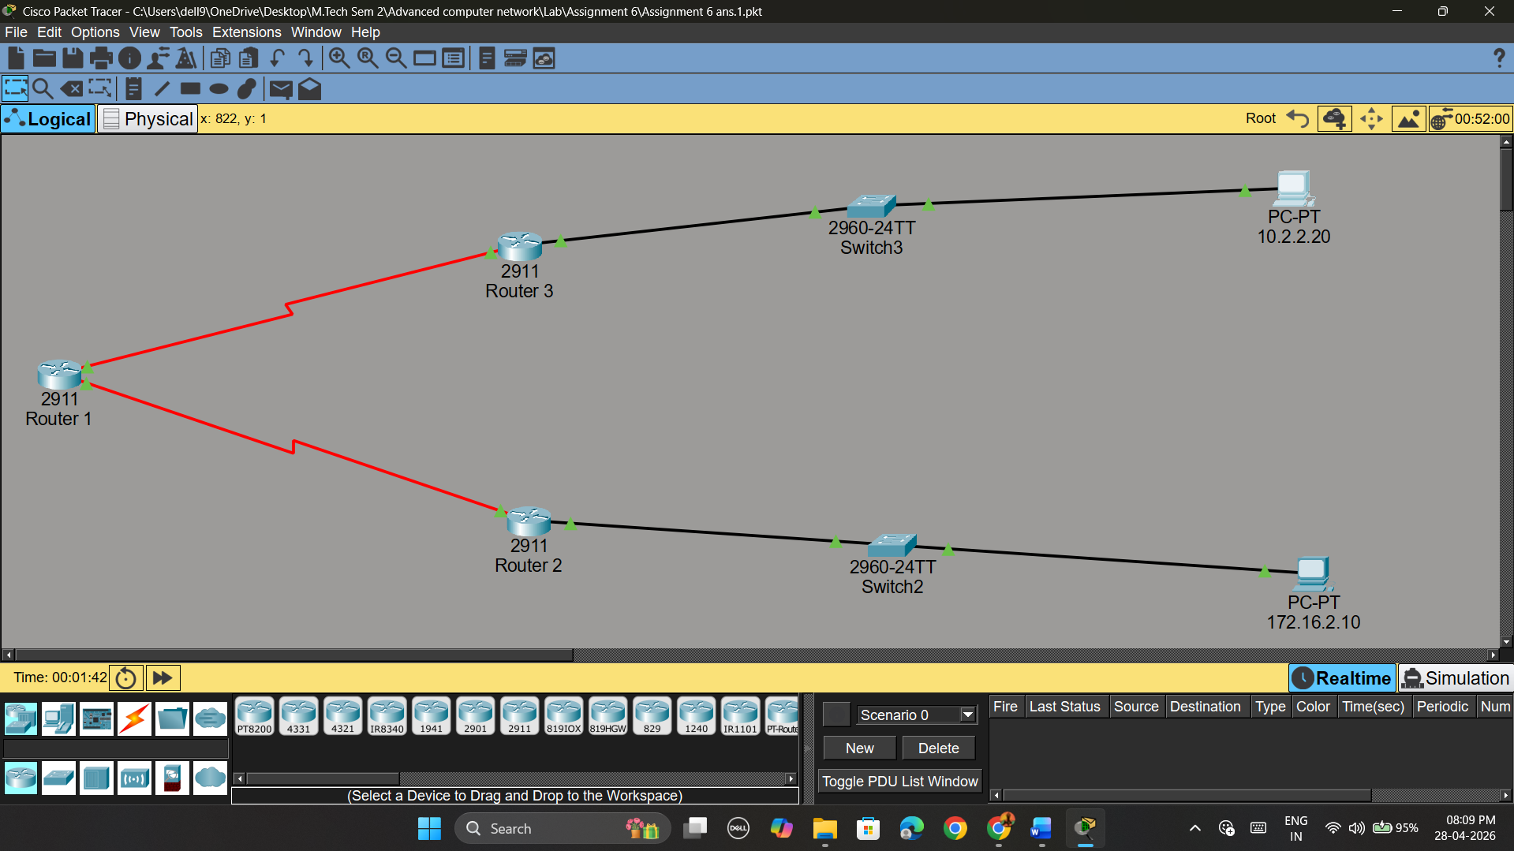

ASSIGNMENT 7

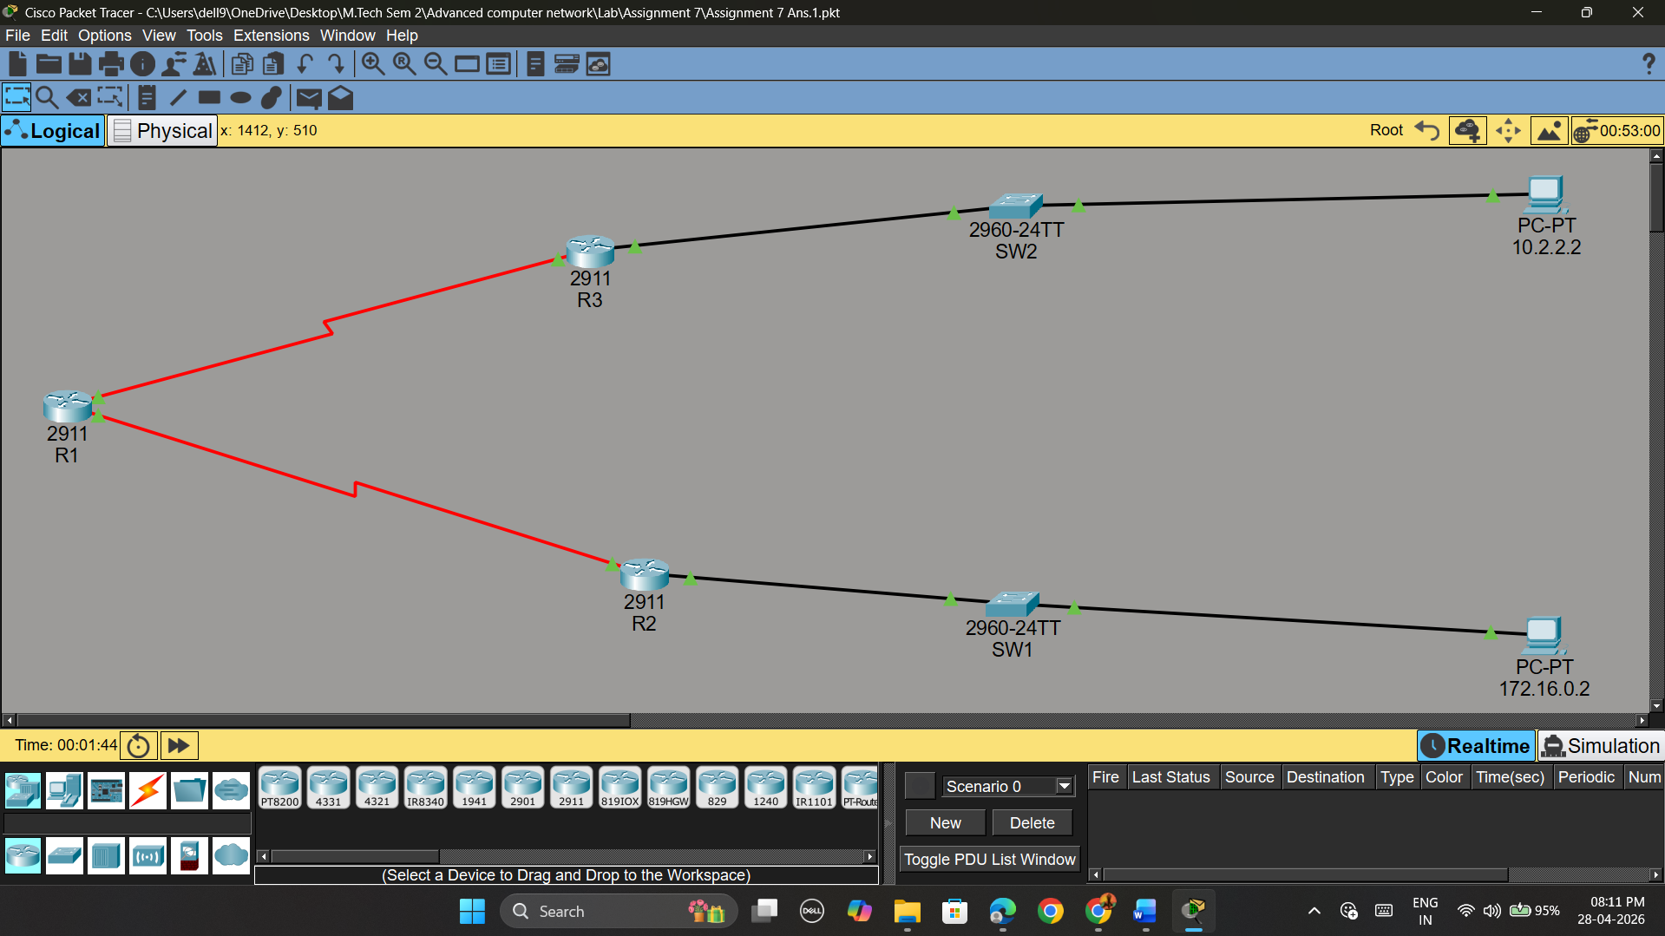

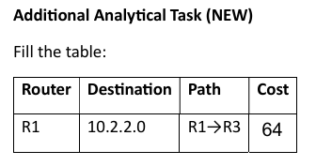

ASSIGNMENT 8

